History of Women
Student’s Name
Institutional Affiliation

American Women History (political equality)
Primary sources
- Primary Source - Anna Howard Shaw, NAWSA Convention Speech (1913)
- Primary Source - Doris Stevens, Account of NWP Picketing (1920)
- Primary Source – Elizabeth Cady Stanton, Declaration of Sentiments (1848)
Introduction
Women have undergone many milestones in terms of political equality in the United States. Political equality for women has gone through significant steps, and it has taken the effort of many women who sought to seek for political equality. This paper uses three primary sources to show political balance in the history of men in America. The fight for political equality can be traced back in 1848 when the first women convention was held at Seneca Falls, New York led by Elizabeth candy Stanton. In the convention, women identified their natural and inalienable rights that women had been deprived. The second primary source discussed in the paper is Anna Howard Shaw, NAWSA Convention Speech (1913), which shows how women were denied the right to vote. The third and last primary source is the Doris Stevens, Account of NWP picketing (1920), which demonstrates how women were denied the rights to picket. The paper also shows some images of the primary sources in the history of women as far as political equality is concerned.

Elizabeth Cady Stanton, Declaration of Sentiments (1848)
This is one of the primary sources which shows the political history of women in America. It is the report of the women's rights convention, which was held at Seneca Falls, New York on July 19th and 20th, 1848. Elizabeth Candy Stanton convened the assembly. It was the first women's convention organized by women. The convention held that all men and women are created equal, and their creator endows them with certain inalienable rights, which include life, liberty, and the pursuit of happiness. To secure these rights, governments are instituted, deriving their just powers from the consent of the governed. Whenever the government destroys these ends, those who suffer have the right to refuse allegiance to it and to insist on the institution of a new government. The statement in the convention showed that women were dissatisfied with the government of the time and that they were demanding the equal station to which they were entitled. The convention stated that the history of humanity is a history of repeated injuries and usurpations on the part of women towards women. The facts to prove this included that man has never permitted a woman to exercise her inalienable right to the elective franchise. Secondly, man has compelled the woman to submit to laws in a form in which she is voiceless. Thirdly, men have been forcing women to submit to rules which are given to the most ignorant and degraded men. By denying the women the right of a citizen, the elective franchise, man has left her with no representation in the halls of legislation. Hughes, S. S., & Hughes, B. (2015
The convention highlighted other oppressions that women faced at the moment. They included being sidelined in church affairs, the right to own property, monopoly of all profitable employment, rights of marriage, educational rights. Due to the above inequalities, women felt aggrieved, oppressed and fraudulently deprived of their most sacred rights. The convention advocated for direct admission to all rights and privileges that belonged to them as US citizens. Women promised to employ agents, petition the state and national legislatures and, circulate tracts. Generally, the convention showed how the US government had oppressed women by not granting them equal rights that men of all calibre enjoyed. This primary source is significant because it led to a Declaration of Sentiments modelled on the Declaration of independence. The Declaration demanded a variety of rights for women, including suffrage. The convention was the starting point for the long journey for the fight of rights of women because 18 years later, the leader of the convention Elizabeth Cady Stanton, became the first woman to run for the United States House of Representatives despite being ineligible to vote. Hughes, S. S., & Hughes, B. (2015

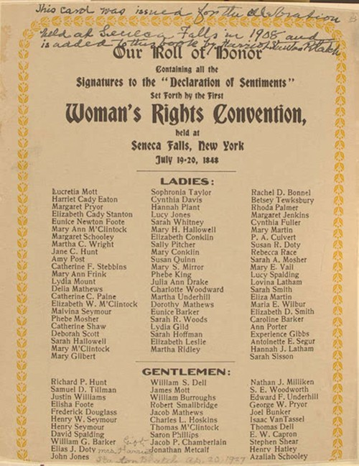

Anna Howard Shaw, NAWSA Convention Speech (1913)
Anna Howard Shaw Remarks on Emotionalism in politics at the National Women Suffrage Association Convention in 1913. I her speech she points out that by some objectors, women are not supposed to vote because they are hysterical and emotional. Men would not like to have emotions enter into a political campaign. They want to cut all, and they want to cut women out. She says that she went to the last Democratic national convention in Baltimore to witness the calmness of the male politicians. What she observed was contrary to what she expected. Men were yelling and screaming, and others whooping and howling very loudly. Men were jumping up on the seats and throwing their hats in the air.no hysteria about it but patriotism, loyalty and splendid manly devotion to principle. Anna says that she has been to many women's conventions, but she had not witnessed leaping upon a chair and take off her bonnet and toss it in the air. She had never had any woman yelling and whooping for five minutes when somebody's name was mentioned. But women admit that they are emotional. Spring, J. (2016).
The speech by Anna forms the foundation for the fight for voting rights for women. From the speech, women are considered hysterical and emotional, but Anna refutes that with the evidence from the behaviour she saw with men during a political rally. This shows the long journey that women have gone until they were granted the right to vote. The fruits of this speech were seen seven years later when the 19th Amendment to the US constitution was ratified, giving women the right to vote. Spring, J. (2016).
There have also been other significant milestones achieved by women, not just voting rights. For example, they were elected to Congress, supreme courts, mayor, and governors. Further advances have seen Black women serving in the Congress (Shirley Chisholm, 1968), lesbian/gay woman serving as state legislature (Elaine Noble, 1974), Arab American women being elected to Congress (Mary Rose Oakar, 1976). The latest political advancements by women include Hilary Rodhan Clinton who became the first woman to be a major party’s presumptive nominee for president although she lost the presidential election in 2016. In 2018, Ilham Omar and Rashida Tlaib became the first Muslim women elected to Congress. This shows the significant steps that women have taken in the political arena, starting from voting rights to vying for the presidential election. Spring, J. (2016).
Anna Howard Shaw, NAWSA Convention Speech (1913)
In this primary source, Doris Stevens talks about the first arrest of pickets in June 1917. Women were not allowed to picket. Doris reports of a confrontation with one Major Pullman, The chief police who was trying to bar women from picketing. The police officer threatened to arrest women. The women argued that they had picketed for six months and that they had the legal right to picket. The following day Miss Lucy Burns and Miss Katharine Morey went to the White House Gates with a banner reading “we shall fight for the things we’ve always held nearest to our hearts…" It is evident that during this time, the rights of the picketing of women was still suppressed by men. Jones, N. (2016).
Conclusion
In summary, this paper has discussed the history of political equality of women in the United States using three primary sources. The primary sources are Elizabeth Cady Stanton, Declaration of Sentiments (1848), Anna Howard Shaw, NAWSA Convention Speech (1913) and Anna Howard Shaw, NAWSA Convention Speech (1913). These sources are used to show the milestones that women have strived to achieve from 1848 to date. The paper shows how women have fought for political equality and other rights throughout history, starting from voting rights to being elected to Congress and finally vying for a presidential election. This calls for respect for women because they have demonstrated their ability in terms of politics and other affairs. Political equality should be embraced for both men and women in the 21st century.

References.
Spring, J. (2016). Deculturalization and the struggle for equality: A brief history of the education of dominated cultures in the United States. Routledge.
Hughes, S. S., & Hughes, B. (2015). Women in World History: v. 2: Readings from 1500 to the Present. Routledge.
Jones, N. (2016). Gender and the political opportunities of democratization in South Korea. Springer.
.

